[Date]
Good morning,

I am writing on behalf of Director [John Smith]. We are pleased to announce that [Company] will become a Recovery-Friendly Workplace in 2019!

The Recovery-Friendly Workplace designation from the Nevada Department of Health and Human Services indicates that [company name] offers tools, resources, services, and technical assistance to employees who are struggling with substance misuse. By encouraging and supporting treatment, we can help reduce the negative effects of alcohol and drug addiction in our workplace and in our employees’ lives.

It is a myth that employees experiencing personal problems are “trouble” or are “bad” employees. The majority of people in the workforce want to do well and want to contribute, but personal issues and problems can interfere with that goal. It’s not only a practical matter for us as an employer to help employees struggling at work due to a personal problem, it’s also the right thing to do.

A Recovery-Friendly Workplace also helps to reduce the stigma of substance misuse and encourages employees to support treatment and recovery. [Company name] educates staff and supervisors on substance use and recovery, and we have policies and procedures to support recovery of an employee or support them in caring for a family member in recovery.

Please take some time to familiarize yourself with the program. Information about this Nevada designation is online at: recoveryfriendlyworkplace.nv.gov

Please ensure this email is forwarded to everyone in your branch.
Thank you,

Jane Doe
Executive Assistant to Director John Smith
Recovery Friendly Workplace Company
9999 Recovery Way, Suite 100 | Addiction Free, USA 17760
T: (098) 765-4321 | E: jane.doe@email.com

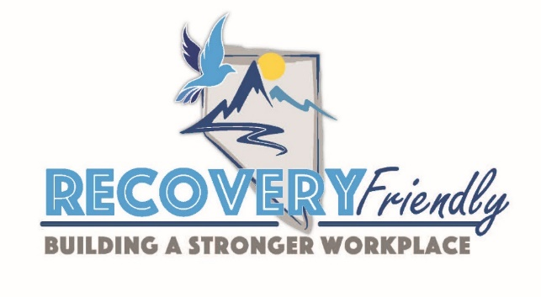
Recovery is possible. Treatment works. We are “Recovery Friendly”

